Hybrid Cloud Network Project Documentation
Complete documentation for the Hybrid Cloud Network Project covering Weeks 1 to 6. This report includes device configurations, IP addressing, VPN setup, connectivity tests, screenshots, diagrams, team roles, and deliverables.

Introduction
This project demonstrates a hybrid cloud network connecting an on-premise network with a cloud environment using GNS3, VirtualBox VM, Docker containers, and StrongSwan for IPsec VPN. The on-premise network includes a Cisco router and Ubuntu server, while the cloud environment consists of Docker-based Cloud Server and StrongSwan VPN Gateway. The project covers planning, setup, implementation, testing, and documentation over six weeks.

Week 1: Planning and IP Addressing
Week 1 focused on planning, defining the hybrid cloud topology, assigning roles, and preparing resources.

IP Addressing Plan
Device | Role / Notes | IP Address | Subnet Mask
Windows Host | Host machine for GNS3 VM | 192.168.56.101 | 255.255.255.0
Cisco Router (R1) | Routing between On-Prem & Cloud | 172.16.1.1 / 10.0.0.1 / 192.168.100.1 | 255.255.255.0 for each interface
Ubuntu-OnPrem-Server | On-Premise server | 172.16.1.10 | 255.255.255.0
Cloud-Server | Cloud server Docker Guest | 10.0.0.10 | 255.255.255.0
StrongSwan-Gateway | IPsec VPN endpoint | 10.0.0.1 | 255.255.255.0

Week 2: Environment Setup
Week 2 involved setting up the GNS3 VM, VirtualBox, Docker containers, and basic connectivity verification. Screenshots and topology verification were captured.

Week 5: VPN Implementation and Testing
Week 5 focused on implementing the IPsec VPN between the Cisco router and StrongSwan Gateway, including configuration and verification.

Network Topology

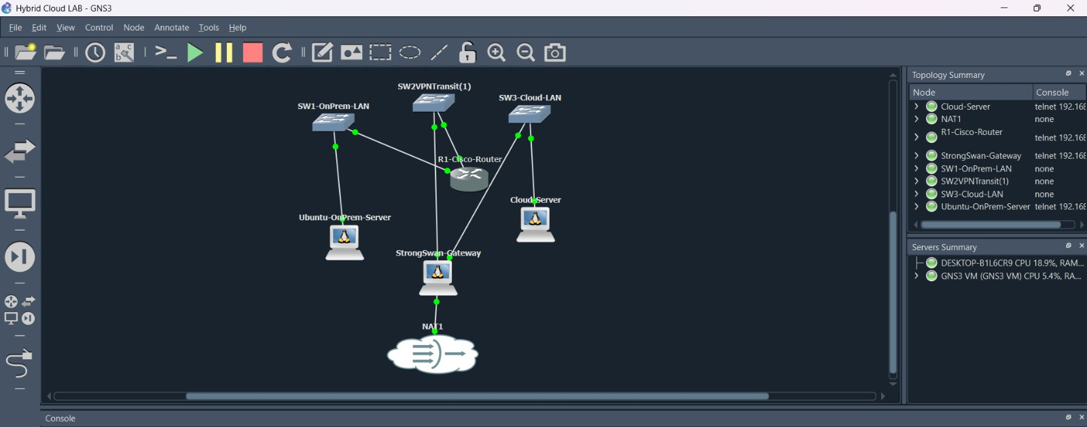

Screenshots & Configurations
Router Configs
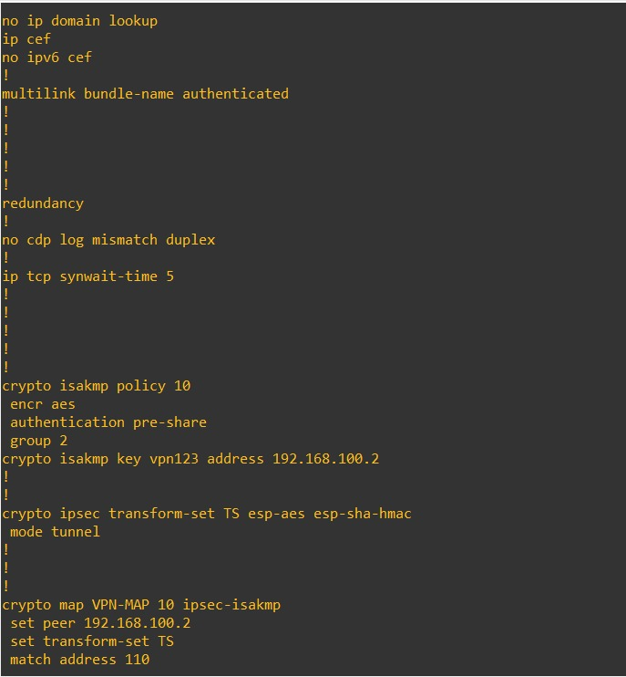


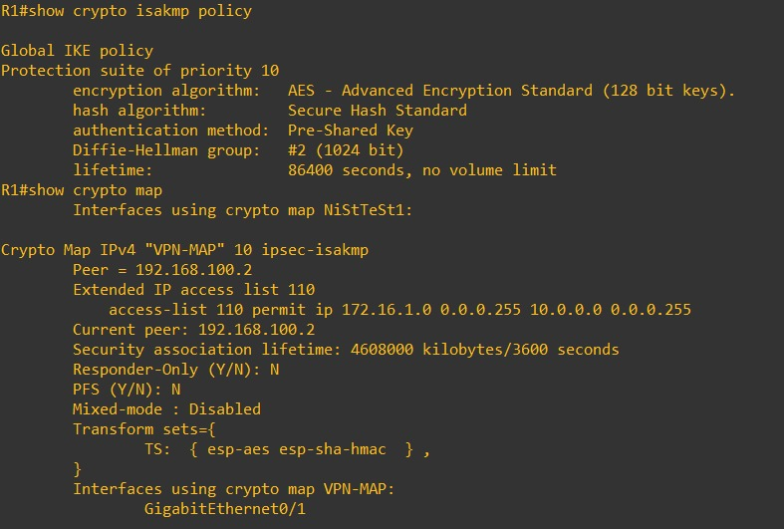


Cloud Server Configs
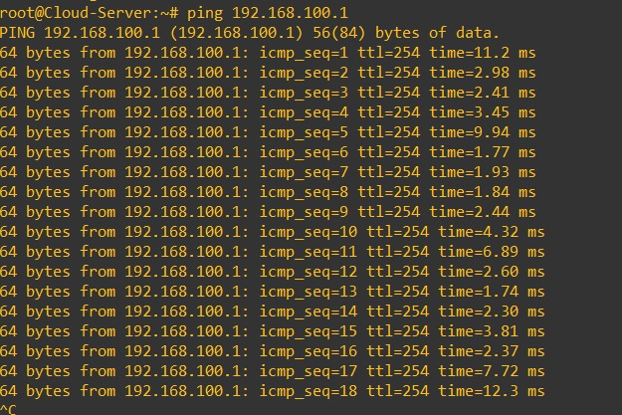


StrongSwan Gateway Configs
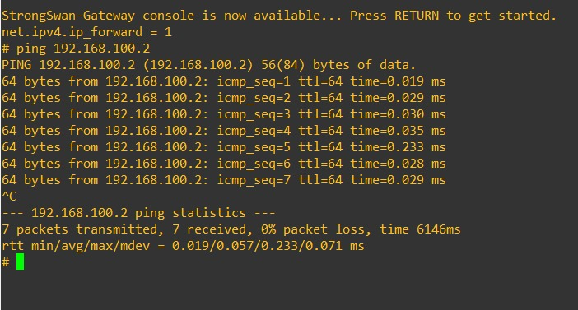
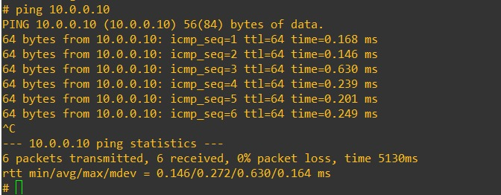
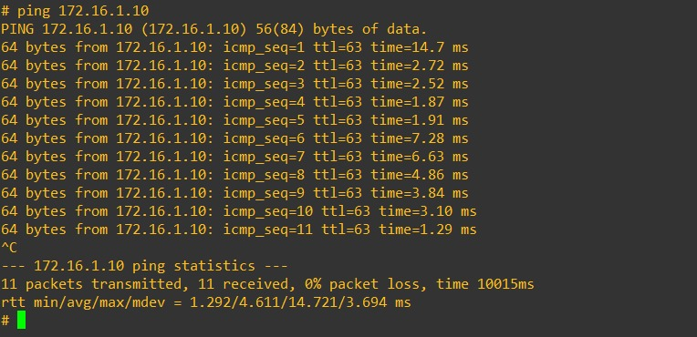


Ubuntu
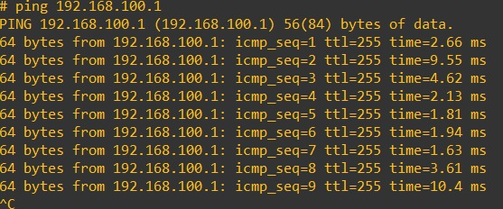
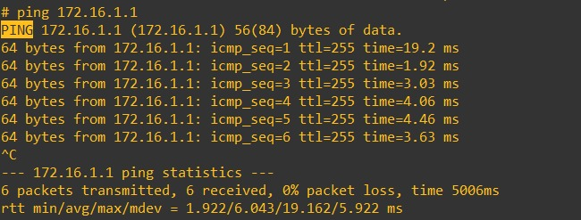

Team Members & Roles
Team Member | Role | Tasks Assigned
Muhammad Hassan Ijaz | Project Lead / Network Architect | Router and switch configuration, IP addressing, routing, topology diagrams, connectivity tests, VPN verification
Muhammad Taufeeq Majeed | Security & Cloud Engineer | StrongSwan VPN Gateway setup, Cloud server configuration, Docker management, IPsec implementation, connectivity verification, documentation

Conclusion
This Hybrid Cloud Network Project successfully demonstrates integration of an on-premise network with a cloud environment using GNS3, Docker containers, and StrongSwan IPsec VPN. The document includes detailed configurations, screenshots, and step-by-step explanations from planning to final verification.

